**ARCHITECTURAL DIAGRAMS**

**Class Diagram**

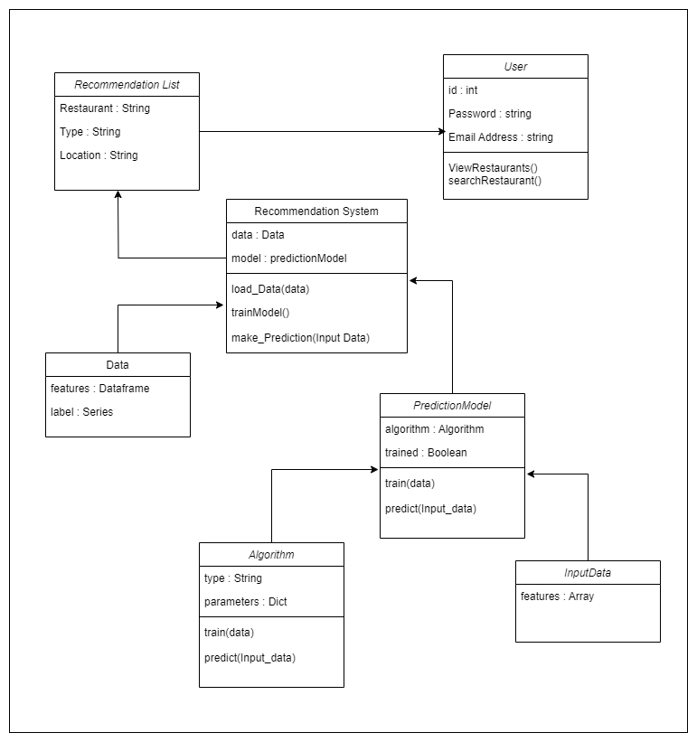

**BEHAVIOURAL DIAGRAMS**

**Data Driven Models**

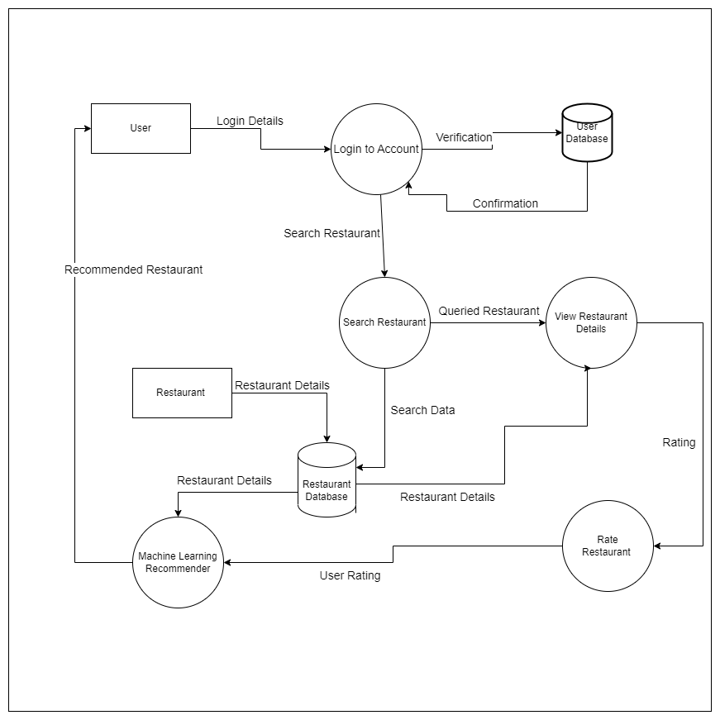

**Flowcharts**

**Authentication Flowchart**

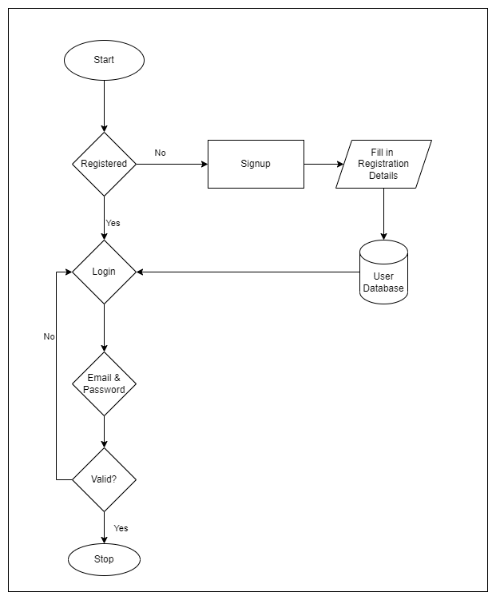

**System Flowchart**

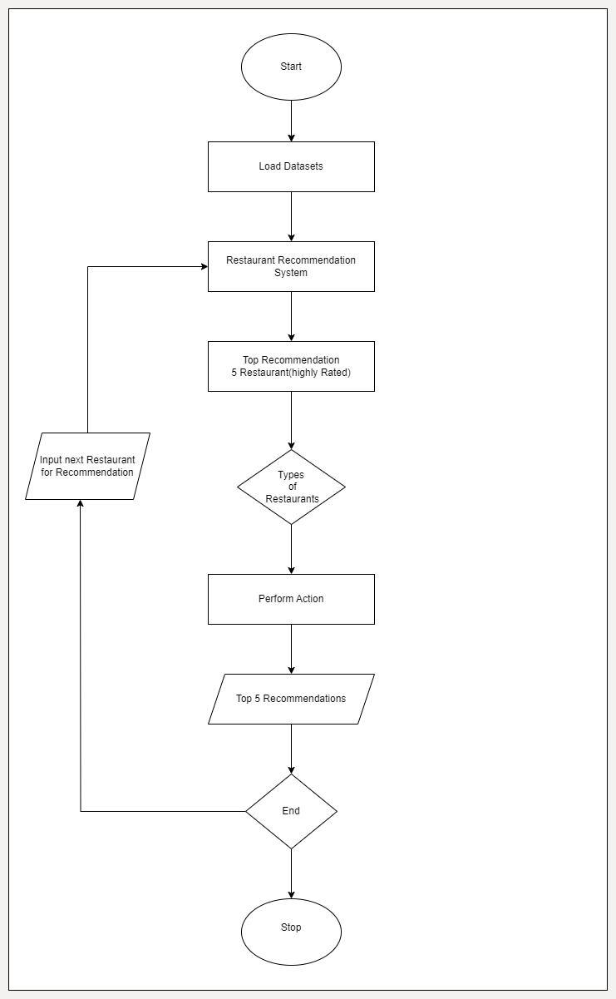

**Use cases**

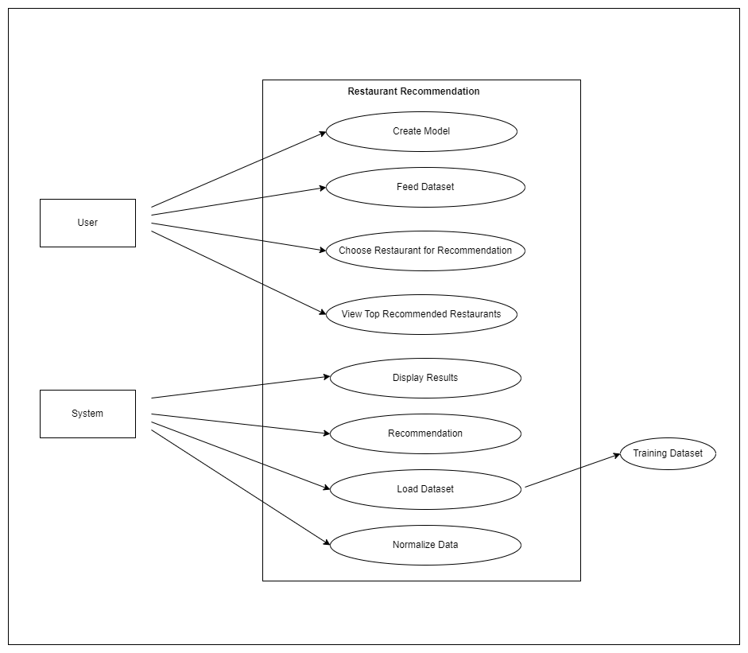

**Sequence Diagrams**

**Authentication Sequence Diagram**

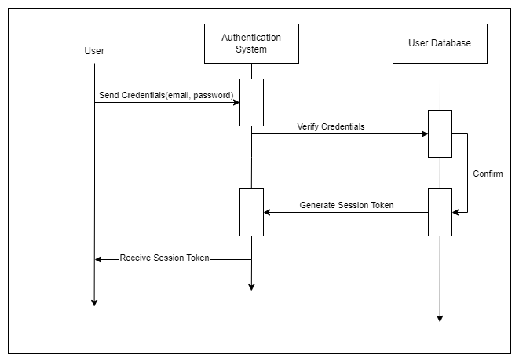

**Recommendation System Sequence Diagram**

